**Multi Protocol Label Switching**



***BY: ALEKSIE SANCHEZ MEDEIROS***

**

***Purpose***

To gain an understanding of how to configure multiprotocol label switching across a network consisting of both multilayer switches and routers.

***Background***

Multiprotocol Label Switching (MPLS) is used to make forwarding packets in networks much more efficient. MPLS began development in the early 90s as not only a solution to existing limitations in traditional routing but also to make customizable paths for network traffic. The main difference between MPLS and IP routing is the use of labels. In IP routing the traffic across a network is moved based on the destination, routers determine the path using routing tables which could eventually lead to issues with scalability and performance with a large enough network. The usage of these labels was done to enable faster forwarding decisions by only reading the label on the packet and not the entire IP header and even control where certain traffic will go called Label-Switched Paths (LSP). In order for the labels to be distributed MPLS relies on a Label Distribution Protocol (LDP) in order to determine the labels that a router would receive. These routers would become LDP peers and would work together to create an LSP database similar to routing tables. When sending packets, routers will look at the incoming label, determine where it goes and switch the outgoing label to the next one of the next router. This use of MPLS can be used to explicitly specify where traffic should go to ensure privacy or quality of service. MPLS, however, doesn’t do away with IP routing completely as it does use existing IP routing infrastructure, such as OSPF in the case of this lab.

OSPF is a non-proprietary routing protocol that enables manual route creation and works with MPLS. It uses a link state routing algorithm to establish the best connectivity between routers on a network. OSPF handles network disconnections and issues which may occur on a network, without requiring manual intervention.

***Lab summary***

At the end of the lab we had configured IPv4 connectivity between the end devices across the 3 multilayer switches using MPLS, in addition to the routers using OSPF for routing.

***Lab Commands***

***mpls label protocol ldp*** is a command which tells the router to specifically use LDP for label distribution with MPLS.

***mpls ip*** is used on an interface to enable forwarding using mpls which will assign labels to the packets.

***no switchport*** turns off switching on the switch and allows for the interface to use ip routing for sending packets.

***Network Diagram***

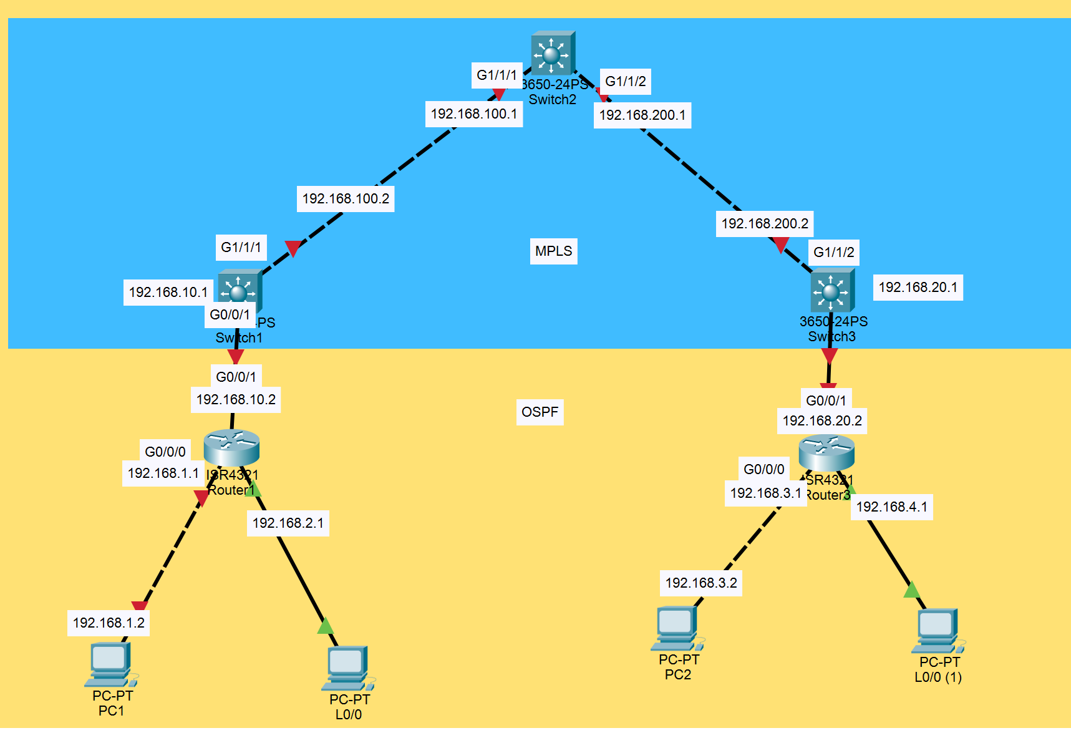  
***Router and Switch Configurations***

***S1:***

version 12.2

no service pad

service timestamps debug datetime msec

service timestamps log datetime msec

no service password-encryption

hostname S1

boot-start-marker

boot-end-marker

no aaa new-model

system mtu routing 1500

ip routing

vtp domain cisco

vtp mode transparent

mpls label protocol ldp

crypto pki trustpoint TP-self-signed-2306271616

enrollment selfsigned

subject-name cn=IOS-Self-Signed-Certificate-2306271616

revocation-check none

rsakeypair TP-self-signed-2306271616

spanning-tree mode pvst

spanning-tree extend system-id

vlan internal allocation policy ascending

interface FastEthernet1/0/1

no switchport

ip address 192.168.10.1 255.255.255.0

interface FastEthernet1/0/2

interface FastEthernet1/0/3

interface FastEthernet1/0/4

interface FastEthernet1/0/5

interface FastEthernet1/0/6

interface FastEthernet1/0/7

interface FastEthernet1/0/8

interface FastEthernet1/0/9

interface FastEthernet1/0/10

interface FastEthernet1/0/11

interface FastEthernet1/0/12

interface FastEthernet1/0/13

interface FastEthernet1/0/14

interface FastEthernet1/0/15

interface FastEthernet1/0/16

interface FastEthernet1/0/17

interface FastEthernet1/0/18

interface FastEthernet1/0/19

interface FastEthernet1/0/20

interface FastEthernet1/0/21

interface FastEthernet1/0/22

interface FastEthernet1/0/23

interface FastEthernet1/0/24

interface GigabitEthernet1/0/1

interface GigabitEthernet1/0/2

interface GigabitEthernet1/1/1

no switchport

ip address 192.168.100.2 255.255.255.0

speed auto 1000

mpls ip

interface GigabitEthernet1/1/2

interface Vlan1

no ip address

router ospf 1

network 192.168.10.0 0.0.0.255 area 0

network 192.168.100.0 0.0.0.255 area 0

ip http server

ip http secure-server

logging esm config

line con 0

line vty 0 4

login

line vty 5 15

login

end

***S2:***

version 12.2

no service pad

service timestamps debug datetime msec

service timestamps log datetime msec

no service password-encryption

hostname S2

boot-start-marker

boot-end-marker

no aaa new-model

system mtu routing 1500

ip routing

mpls label protocol ldp

spanning-tree mode pvst

spanning-tree extend system-id

vlan internal allocation policy ascending

interface FastEthernet1/0/1

interface FastEthernet1/0/2

interface FastEthernet1/0/3

interface FastEthernet1/0/4

interface FastEthernet1/0/5

interface FastEthernet1/0/6

interface FastEthernet1/0/7

interface FastEthernet1/0/8

interface FastEthernet1/0/9

interface FastEthernet1/0/10

interface FastEthernet1/0/11

interface FastEthernet1/0/12

interface FastEthernet1/0/13

interface FastEthernet1/0/14

interface FastEthernet1/0/15

interface FastEthernet1/0/16

interface FastEthernet1/0/17

interface FastEthernet1/0/18

interface FastEthernet1/0/19

interface FastEthernet1/0/20

interface FastEthernet1/0/21

interface FastEthernet1/0/22

interface FastEthernet1/0/23

interface FastEthernet1/0/24

interface GigabitEthernet1/0/1

interface GigabitEthernet1/0/2

interface GigabitEthernet1/1/1

no switchport

ip address 192.168.100.1 255.255.255.0

speed auto 1000

mpls ip

interface GigabitEthernet1/1/2

no switchport

ip address 192.168.200.1 255.255.255.0

speed auto 1000

mpls ip

interface Vlan1

no ip address

router ospf 1

network 192.168.100.0 0.0.0.255 area 0

network 192.168.200.0 0.0.0.255 area 0

ip http server

ip http secure-server

logging esm config

line con 0

line vty 5 15

end

***S3:***

version 12.2

no service pad

service timestamps debug datetime msec

service timestamps log datetime msec

no service password-encryption

hostname S3

boot-start-marker

boot-end-marker

no aaa new-model

system mtu routing 1500

ip routing

vtp domain CCNP

vtp mode transparent

mpls label protocol ldp

spanning-tree mode pvst

spanning-tree extend system-id

vlan internal allocation policy ascending

interface FastEthernet1/0/1

no switchport

ip address 192.168.20.1 255.255.255.0

interface FastEthernet1/0/2

interface FastEthernet1/0/3

interface FastEthernet1/0/4

interface FastEthernet1/0/5

interface FastEthernet1/0/6

interface FastEthernet1/0/7

interface FastEthernet1/0/8

interface FastEthernet1/0/9

interface FastEthernet1/0/10

interface FastEthernet1/0/11

interface FastEthernet1/0/12

interface FastEthernet1/0/13

interface FastEthernet1/0/14

interface FastEthernet1/0/15

interface FastEthernet1/0/16

interface FastEthernet1/0/17

interface FastEthernet1/0/18

interface FastEthernet1/0/19

interface FastEthernet1/0/20

interface FastEthernet1/0/21

interface FastEthernet1/0/22

interface FastEthernet1/0/23

interface FastEthernet1/0/24

interface GigabitEthernet1/0/1

interface GigabitEthernet1/0/2

interface GigabitEthernet1/1/1

interface GigabitEthernet1/1/2

no switchport

ip address 192.168.200.2 255.255.255.0

speed auto 1000

mpls ip

interface Vlan1

no ip address

shutdown

router ospf 1

network 192.168.20.0 0.0.0.255 area 0

network 192.168.200.0 0.0.0.255 area 0

ip http server

ip http secure-server

logging esm config

line con 0

line vty 5 15

end

***R1:***

version 16.9

service timestamps debug datetime msec

service timestamps log datetime msec

platform qfp utilization monitor load 80

no platform punt-keepalive disable-kernel-core

hostname R1

boot-start-marker

boot-end-marker

vrf definition Mgmt-intf

address-family ipv4

exit-address-family

address-family ipv6

exit-address-family

no aaa new-model

login on-success log

subscriber templating

vtp domain cisco

vtp mode transparent

multilink bundle-name authenticated

license udi pid ISR4321/K9 sn FDO21482HZX

no license smart enable

diagnostic bootup level minimal

spanning-tree extend system-id

redundancy

mode none

interface Loopback0

ip address 192.168.2.1 255.255.255.0

interface GigabitEthernet0/0/0

ip address 192.168.1.1 255.255.255.0

negotiation auto

interface GigabitEthernet0/0/1

ip address 192.168.10.2 255.255.255.0

negotiation auto

interface Serial0/1/0

no ip address

shutdown

interface Serial0/1/1

no ip address

shutdown

interface GigabitEthernet0

vrf forwarding Mgmt-intf

no ip address

shutdown

negotiation auto

router ospf 1

network 192.168.1.0 0.0.0.255 area 0

network 192.168.2.0 0.0.0.255 area 0

network 192.168.10.0 0.0.0.255 area 0

ip forward-protocol nd

no ip http server

no ip http secure-server

ip tftp source-interface GigabitEthernet0

control-plane

line con 0

transport input none

stopbits 1

line aux 0

stopbits 1

line vty 0 4

login

end

***R2:***

version 16.9

service timestamps debug datetime msec

service timestamps log datetime msec

platform qfp utilization monitor load 80

platform punt-keepalive disable-kernel-core

hostname R2

boot-start-marker

boot-end-marker

vrf definition Mgmt-intf

address-family ipv4

exit-address-family

address-family ipv6

exit-address-family

no aaa new-model

login on-success log

subscriber templating

vtp domain cisco

vtp mode transparent

multilink bundle-name authenticated

crypto pki trustpoint TP-self-signed-2105456491

enrollment selfsigned

subject-name cn=IOS-Self-Signed-Certificate-2105456491

revocation-check none

rsakeypair TP-self-signed-2105456491

crypto pki certificate chain TP-self-signed-2105456491

certificate self-signed 01

4F532D53 656C662D 5369676E 65642D43 65727469 66696361 74652D32 31303534

35363439 31308201 22300D06 092A8648 86F70D01 01010500 0382010F 00308201

0A028201 0100CB50 2C0E203C ED2B3187 75841E77 7154DAB7 C39264E9 78ACCC80

76FBEB8D D6488562 03D6E9C5 12E38DD1 F63A4497 DDCCFECF 6725CB95 BE8F4C32

78C1CF55 84BDFE6A B8B67F9C 94F8222F 18479604 2862467D 0756F0E5 7FE767FE

A5D1BA91 617652FD 035CBDDB 71996605 DECF487E A4C1B917 7FFB733F 473B7B58

16EB06B0 F9DCABD6 3EF70058 331992EC 511B0206 6334D93F A2A4FAF2 0C10A880

515F5F41 9947A310 4FE105EF 1E73EC71 95D53860 A997E73B 0423BB90 5A34F53A

E0E30C9F 5DE814D1 91C92975 E90EB367 EAABBC5B 8BF25368 BF97C06F 747C18A8

100C1792 A881B10B 539A0239 712B1F0C 1DDC8B69 9B48DD8C F4243DBC 9DA3B8A7

E907099C 4B750203 010001A3 53305130 0F060355 1D130101 FF040530 030101FF

301F0603 551D2304 18301680 1412CA6D 74BA35C6 3A393C00 41E833D4 78D803E2

AA301D06 03551D0E 04160414 12CA6D74 BA35C63A 393C0041 E833D478 D803E2AA

300D0609 2A864886 F70D0101 05050003 82010100 B31047C0 C4F62EAE 78E03B0E

5232DB49 A1C6330C C84ABCC6 8D6A9BD3 D168D786 B4E1C030 DC82C943 7FE0F73C

9088021D 68915B30 C554DF26 A10DCBF5 D6E965BF E459DDBE 8E87589C F88A0B5D

1F0CBF9F C09B26DC 406828DC 67637F98 C78BC746 EA5FB3C9 06AD51B2 34B614CE

A04CA88B D1190D4D EBDCE1E7 59342399 36855567 9A024066 E5B97A91 B1F19820

F43B56DE 07840D76 78D431A4 F7377504 B368D855 98212877 0811DA3B E498BF80

7426B55D 0C9BF891 EE53DDC2 79E65389 D4639BA2 D26367FB 80B6D35C 004831F5

394A86EF 168E88D2 8876D7F8 FD22B6E4 A8F93CA1 9C163271 193D249B 2828E775

E7222F82 B4A5F943 E7C2B19F BE2DE371 B9EF02DF

quit

license udi pid ISR4321/K9 sn FDO21482DWJ

no license smart enable

diagnostic bootup level minimal

spanning-tree extend system-id

redundancy

mode none

interface Loopback0

ip address 192.168.4.1 255.255.255.0

interface GigabitEthernet0/0/0

ip address 192.168.3.1 255.255.255.0

negotiation auto

interface GigabitEthernet0/0/1

ip address 192.168.20.2 255.255.255.0

negotiation auto

interface Serial0/1/0

no ip address

shutdown

interface Serial0/1/1

no ip address

shutdown

interface GigabitEthernet0

vrf forwarding Mgmt-intf

no ip address

shutdown

negotiation auto

router ospf 1

network 192.168.3.0 0.0.0.255 area 0

network 192.168.4.0 0.0.0.255 area 0

network 192.168.20.0 0.0.0.255 area 0

ip forward-protocol nd

ip http server

ip http authentication local

ip http secure-server

ip tftp source-interface GigabitEthernet0

control-plane

line con 0

transport input none

stopbits 1

line aux 0

stopbits 1

line vty 0 4

login

end

***Screenshots***

***This is the routing table for the second multilayer switch which verifies connectivity and shows the fact that MPLS is put on top of OSPF.***

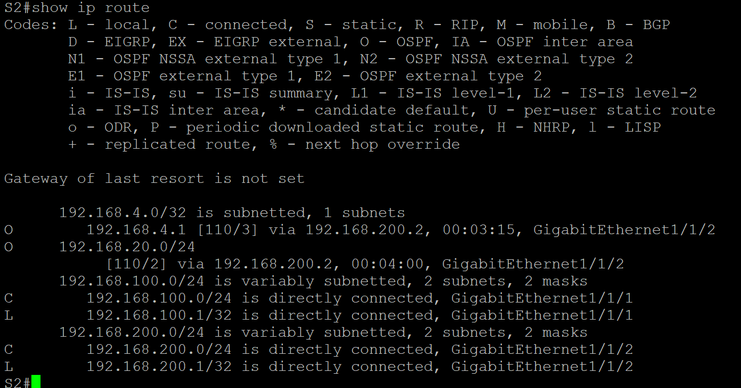

***The screenshot below shows the MPLS forwarding table for the second multilayer switch which was in the middle of the entire topology, notice the labels for the different destinations as well as how it displays how many bytes of data that have gone through that specific label.***

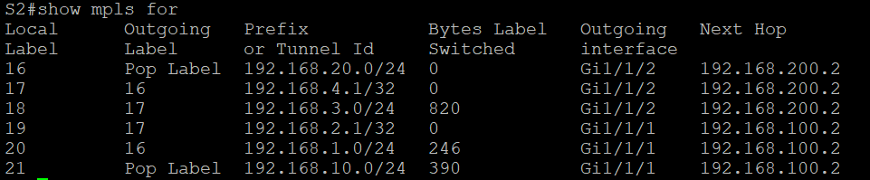

***Problems***

The main issue with setting up MPLS was mostly hardware related, the first of which began with the adapter bit on the ES port of the Multilayer switches, certain ones wouldn’t work. This problem was fixed by testing which ones would work and which did not and ensuring the two would not be mixed up. The other hardware issue was with cables as a lot of them seemed to be inoperative, to fix this I changed out the cables which didn’t work with ones that we knew worked. In general, the rest of the lab was relatively straight forward but the concepts were more complex.

***Conclusion***

In the end, I learnt about how MPLS, by using labels, can be used to direct traffic instead of always choosing the best path or to create faster forwarding by addressing the main limitations with IP routing. In addition to how important it is to not cross off Layer 1 as a source of problems in a network topology.